Use of Machine Learning for creating Dialogs and Behaviors
of an Anchor Monster Robot

Randon Stasney, Ram Bhattarai, Thuan Pham, Tsutomu Sasao, Martin Lukac, and Marek Perkowski
Department of Electrical and Computer Engineering, Portland State University, Portland 97207-0751, Oregon,
In winter quarter students have to implement this system and complete this paper. What is not clear, ask me. Please add more details to this text. Explain better what is not clear.
Abstract
Paper presents the concept of inexpensive natural-size humanoid caricature robot Anchor Monster – an actor for Portland Cyber Theatre; an agent for advertisement, education and entertainment. The robot accepts commands from the Kinect device via OpenCV and is controlled and interacted with using three modes: Vision – of human gestures, Speech via microphone array in Kinect from human and a typed text from a Smartphone. Once the gesture information and voice commands from Kinect and smartphone are passed via serial communication to the Arduino device that controls the robot, the Arduino program parses the information and implements the developed libraries to control the robot motions and verbal responses. With the created library of input-output behaviors specified as symbols, the robot ready to learn was built. This paper presents briefly the entire architecture of the Monster Anchor, but concentrates on Machine Learning techniques used to teach the Monster humanoid certain robot behaviors, natural language dialogs and facial gestures.

1. Introduction

Future robots that will work in human environments will be quite different from industrial robots. They will interact closely with non-sophisticated users, children and elderly, so the question arises, how they should look like? It is both a result of public opinion pools and our own observations since year 2000 that the robot should look more-or-less like a human, which property will enable users to understand its intentions and program its behaviors in natural and simple ways [8,9]. If human face for a robot, then what kind of a face? Handsome or average, realistic or simplified, normal size or enlarged [7,10]? The most famous example of a robot head is Kismet from MIT [9]. Why was Kismet so successful? We believe that a robot that will interact with humans should have some kind of “personality” and Kismet so far is one of very few robots with “personality”. Everybody who has played and observed closely Kismet will testify to this. How to build robots that will be equipped with this kind of “personality”?

Building a robot head like Kismet is expensive and the robot is perhaps fragile. And what if we want the robot to be built by high school roboticists or undergraduate students and should be inexpensive but reliable in operation? The Muppets of Jim Henson [6] are hard to match examples of puppet artistry and animation perfection – we intend to build robots with this kind of looks and behaviors. Since 1999 we have been building animatronic humanoid robot heads for interactive robot puppet theatre [1], tourist guides and robotic foreign language teachers. While Kismet is a half-child-half-animal [11], we have been trying to animate various kinds of humanoid heads with 4 to 12 DOF, expecting comical and entertaining values. Because it is difficult to build a humanoid face with more than a few DOF, we are building several variants of head kinematics, and we are experimenting with animation of simpler heads on our path to an ultimate prototype with about 20 DOF. We are less interested in beauty and accuracy [8] and more in robot’s personality as expressed by its behavior, facial gestures, emotions and learned speech patterns. We believe that a robot face should be not only friendly but also funny. We found also that several of our early humanoids were really scary to kids less than 8 years old that were even afraid to approach the robots (see Figure 1).
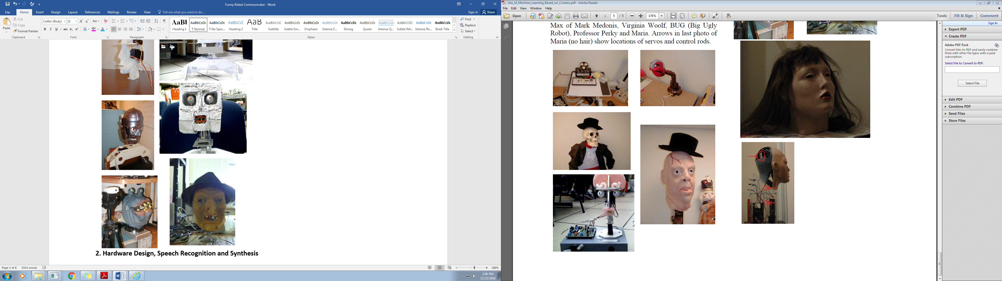
Figure 1.1. First generation of our robot heads. From left to right: Furby head with new control, Alien, Skeleton, Mister Butcher, Marvin the Crazy Robot.

Since 2000 our middle school, high school and undergraduate teams built many robot heads and humanoids. The first generation of heads were built from robot kits, were built from scratch using wood and metal, we adapted Halloween puppets and used available latex masks. We found that using inexpensive commercial latex masks is difficult because of their tearing or lack of flexibility sufficient for facial animation. Some of our robots (Skeleton, BUG and Professor Perky), presented at fairs, were very scary to children that were afraid even to approach them, so we decided to build less scary and more beautiful robots.
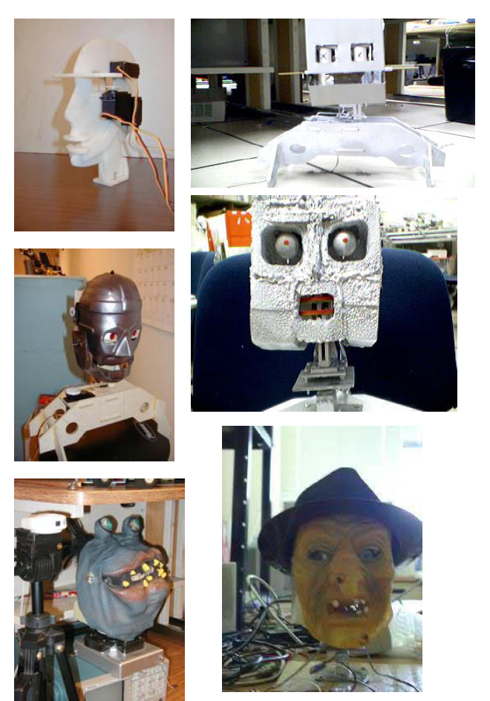
Figure 1.2. Second generation of heads. The robot heads from left to right: alien, Jonas, MAX of Mark Medonis, Virginia Woolf, Big Ugly Robot (BUG) and Professor Perky.

Robots of the second generation had different capabilities: BUG (see Figure 1.2) was first of them equipped with learning based on robot vision, and Professor Perky had automated speech recognition (ASR) and text-to-speech (TTS) capabilities. The motion and speech patterns of these robots were amazing and funny, which was our main goal. The previous robots from Figures 1.1 and 1.2 were not enough human-like and not enough entertaining.

Figure 1.3. Maria. Arrows in last photo of Maria (no hair) show locations of servos and control rods.
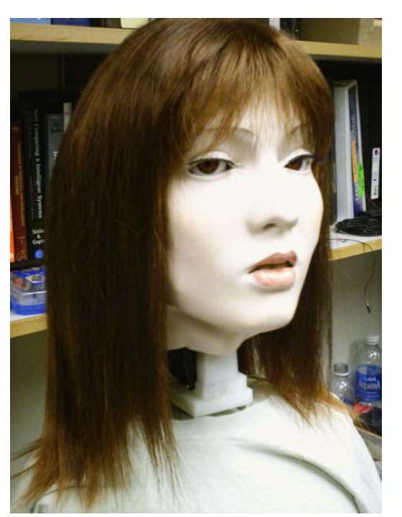
Figure 1.4. The Narrator Robot.
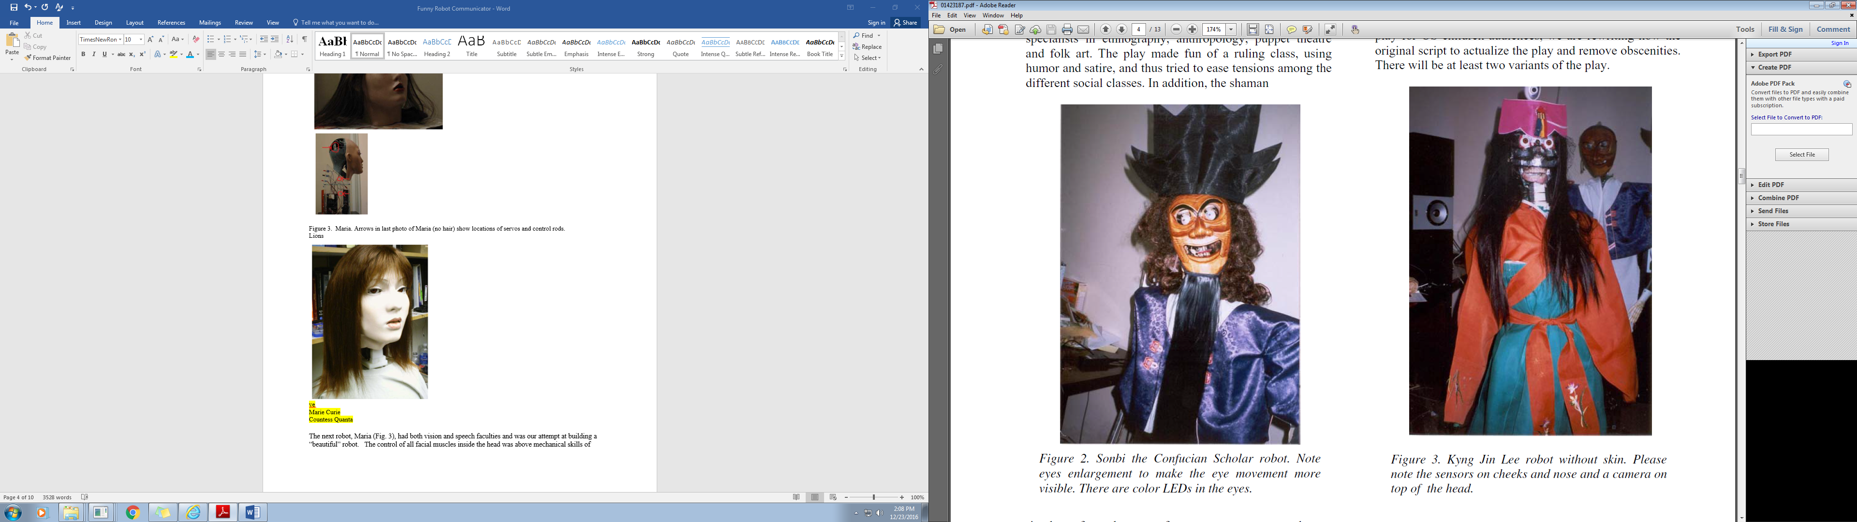
Figure 1.5. The Narrator robot without skin. Please note sensors on cheeks and nose and a camera on top of the head.

Lions

Figure 1.6. Sonbi the Confucian Scholar robot. Note eyes enlargement to make eye movement more visible. There are color LEDs in the eyes.

Figure 1.7. Early version of Monster.

Figure 1.8. Recent version of Anchor Monster.

Figure 1.9. Lips for robot head.

The next robot, Maria (Fig. 1.3), had both vision and speech faculties and was our attempt at building a “beautiful” robot. The control of all facial muscles inside the head was unfortunately above the mechanical skills of students. This robot was not raising laughs and was not liked. Most importantly, we encountered the “Uncanny Valley” problem on this and similar robots, so we gave up on beautiful females and we turned to funny, fuzzy-like men.

Our next robot, Mister Butcher, modified and renamed Professor Niels Bohr, was very funny in his facial gestures, but it was not easy to control all the muscles. Also, the skin deteriorated after about two years of using it, a phenomenon that happened to all latex and rubber facial masks that we used and that were flexible enough to control them. The Narrator robot had good gestures but the expensive skin was too rigid to control most facial gestures (see Figures 1.4 and 1.5). Finally, we built the robot with the Korean Mask modified by us to be a Sonbi Confucian Scholar robot (Figure 1.6). We decided that the head was not funny enough and not easy to animate.

New version of Sonbi was created, with two moveable arms and two moveable legs. It had a rotate-able head with very good animation of a loose latex mask (Figure 1.7). Unfortunately, the neck design needed improvements and the latex mask deteriorated again. In addition, students thought that a head without mask is more interesting as the audience can observe all actions of servos for eyes and eybrows. The robot is gender-free, not a male, neither a female, it can be easily converted to a male or female robot by dress, voice and behavior/language rules. This leads to our final robot head, Anchor Monster, from Figure 1.8.

This robot serves the following purposes:
- Basically, it is a receptionist for Intelligent Robotics Laboratory. Informs about professors, Teaching Assistants, classes and events. It does it in a funny and entertaining way. This student-built robot should be liked by students, the same way as sport mascots such a PSU Viking are liked.
- It can simulate other type of receptionist, such as ECE Department secretary or a cafeteria waiter/receptionist. As such, robot will be used in several Human-Robot Interaction, Natural Language, motion generation and vision projects in robotics classes.
- It is a demo of Kinect, Alexa, and various algorithms such as Genetic Algorithm, Fuzzy Logic, PID controller, Game playing, Speech Recognition and others that are taught and experimented with in an introductory Intelligent Robotics class ECE 478 at PSU.

Concluding on this part. We designed and evaluated several early prototypes of robot heads. The goal was to have a head that is inexpensive, easy to build and expressive, to allow for high quality dialogs and facial gestures. The main principles that we learned in this process were the following:
- the more degrees of freedom in the head and skin, the better the realism of animation, the absolute minimum is two DOF for both eyes, one DOF for jaw, one DOF for lids, one DOF for eyebrows.
- the neck is very important. Two DOF for the neck is the minimum. We built robots with up to seven DOF and their motion was very good. Anchor should be redesigned to have a better neck.
- synchronization of the spoken text and head (especially jaw) movements are very important, lessons from puppet theatre about animation of puppets with few degrees of freedom in neck and head should be learnt.
- the mechanism for lips motion should be developed, see our designs from Figure 1.9.
- the eyes, jaws, and other movable head components should be of an exaggerated size rather than of natural size; similarly to achieve better interaction, the gestures and the speech intonation of the head should be slightly or even grossly exaggerated,
- the sound from speakers should be laud to cover noises coming from motors and gears and for a better theatrical effect, this is also to be improved in current Anchor Monster,
- noise of servos can be also reduced by appropriate animation and synchronization as well as loud speakers,
- One more solution to the noise problem is to isolate the theatre behind the glass window and give the sound to the audience only through speakers.

2. Hardware Design, Speech Recognition and Synthesis

We use inexpensive servos from Hitec and Futaba, plastic, playwood and aluminum for construction. The robots were either PC-interfaced, use simple micro-controllers such as Basic Stamp, or were radio controlled from a PC or by the user. Previous heads were equipped with microphones, USB cameras, sonars and CDS light sensors. Face Maria was designed by David Ng and is commercially available in two
variants. Image processing and pattern recognition uses software developed at PSU, CMU and Intel (public domain software available on WWW). We compared several commercial speech systems from Microsoft, Sensory and Fonix. Based on experiences in highly noisy environments and with a variety of speakers, we selected Fonix for both ASR and TTS for Professor Perky and Maria robots, but in future we
plan to use Alexa because of its high quality operation in noise. We used microphone array from Andrea
Electronics and Kinect. Software is in Visual C++, Visual Basic, Lisp and Prolog [12].

2.1. Legs.
Using Tetrix, Vex and Lynxmotion components, many ideas how legs can be built come to the mind. While some joints might be able to be supported by the servo horn, we knew the legs would weigh more and require a better support structure. A quick tour of the internet turned up the two relevant documents that we used in our leg creation. The first was “Getting Started with TETRIX” a .pdf from the Carnegie Mellon Robotics Academy. This illustrated the bracing required and the mounting techniques for what we were to use in our knee joint. This was further elucidated by the “TETRIX by Pitsco Creator’s Guide” by PJ Graham, Paul Uttley and Tony Allen. Once our legs were built we tested each degree of freedom with a simple arduino sweep program. We used the pendulum frame on which we could mount Frankenstein Monster. Our homework two was then implemented using our newly created legs to explore the fundamentals of Genetic Algorithm.
2.2. Fuzzy Logic
Fuzzy logic is a powerful method to integrate smooth and gradual motion, compared to having on or off motion. It's a must in the robotics world because robots cannot be on and off only, it needs to have in between motion between the two extremes to create realistic and smooth motion. We implemented a fuzzy logic system to smooth Frankenstein’s eye movements. We used the ultrasonic sensors on his shoulders as a tracking mechanism. This was implemented through the use of a fuzzy logic library found in python library called scikit-fuzzy. We based our design on the tipping tutorial. This library allowed us to program our inputs and outputs as fuzzy logic antecedents and consequences. Once we had those variables set up we created the membership functions and defined their shape. We then created the logic by defining the rules that would be implemented. By the python code on our laptop with our microcontroller, the arduino, we were able to get Frankenstein's eyes to track in a smoother manner.
This functionality was not implemented in our final robot mostly because the actual processing in python was happening external to the Arduino on a laptop that was serially connected by the Pololu Wixel. The Wixel presented its own challenges and appeared to work better after we used the shield with the Arduino.

3. Behavior, Dialog and Learning as Combinational Mapping
General diagram of our system is shown in Figure 3.1. We view robot activity as a mapping of the sensed environment and internal states to behaviors and new internal states (emotions, energy levels, etc). Our goal is to uniformly integrate verbal and non-verbal robot behaviors. Let us remember that words communicate only about 35 % of the information transmitted from a sender to a receiver in a human-to-human communication. The remaining information is included in: body movements, face mimics, gestures, posture, external view - so called para-language. Emotions, thoughts, decision and intentions of a speaker can be recognized earlier than they are verbalized.

In brief, the dialog/behavior system has the following components:
- Eliza-like natural language dialogs. Commercial products like Memoni, Dog.Com and Heart, Alice and Doctor all use this technology very successfully – for instance Alice program won the 2001 Turing competition for Natural-Language speaking software robots. This is a “conversational” part of the robot brain, based on pattern matching, parsing and black-board principles. It is also a kind of “operating system” of the robot, which supervises other subroutines.
- Subroutines with logical data base and natural language parsing (like CHAT). This is the logical part of the brain used to find connections between places, timings and all kind of logical and relational reasoning, such as answering questions about location of laboratories and offices in PSU Engineering buildings.
- Use of generalization and analogy in dialog on many levels. Random and intentional linking of spoken language, sound effects and facial gestures. Use of Constructive Induction approach to help generalization, analogy reasoning and probabilistic generations in verbal and non-verbal dialog, like learning when to smile or turn the head away from the human.
- Model of the robot, model of the user, scenario of the situation, history of the dialog, all used in the conversation.
- Use of word spotting in speech recognition rather than single word or continuous speech recognition.
- Avoidance of “I do not know”, “I do not understand” answers from the robot. Our robot will have always something to say, in the worst case, over-generalized, with not valid analogies or even nonsensical and random.

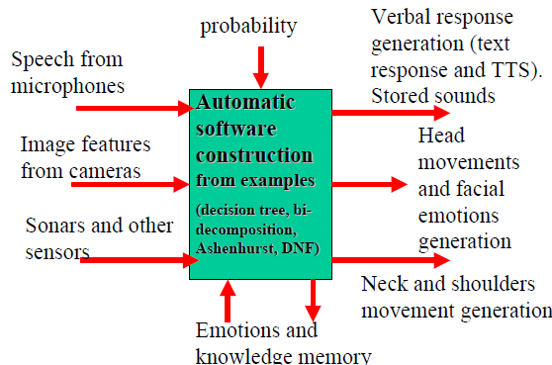

Figure 3.1. Learning Behaviors as Mapping from environment’s features to interaction procedures.

The feature values in Figure 3.1 are extracted from any kind of sensors such as Kinect devices, inexpensive USB cameras, switches, microphone arrays, sonars, etc. [2]. They are stored in a uniform notation of tables [5]. In these tables the rows correspond to samples (minterms, examples) and the columns correspond to feature values (input variables, attributes) of both input variables (sensors, text) and output variables (servos, actuators, TTS). In contrast to standard supervised-learning classifiers that have only one output (decision) variable (yes, no), our tables have many output variables and each variable can be multivalued, and only in special cases binary. This format of a table is a standard format in logic synthesis, Data Mining and Machine Learning. Such tables are created by encoding in the uniform way the data coming from the feature-extracting subroutines based on speech recognition, sensors and image processing. The tables have control parameters given to servos and TTS as their output data. Thus the tables store mapping information. If the input sample used in teaching is encountered again in table’s evaluation, the same exactly output data from the table is produced as found in teaching (rote learning). But what if a new input data is given during evaluation, one that has never appeared before? Here the system makes use of analogy and generalization typical to Machine Learning classifiers.

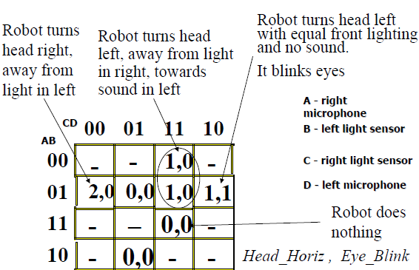
Figure 3.2. Seven examples (4-input, 2 output minterms) are given by the teacher as correct robot behaviors

We will explain this concept on simple examples. Data in tables are stored as binary, and in general muti-valued, logic values (0, 1, 2, etc). The teaching examples that come from preprocessing are stored as multi-output (care) minterms (i.e. combinations of input/output variable values – Fig. 2). For illustration, we use here standard Karnaugh maps (encoded in Gray code) as data, but Binary Decision Diagrams and quite sophisticated logic synthesis algorithms such as Ashenhurst/Curtis hierarchical decomposition and Bi-Decomposition algorithms are used in our software [2,3,4,5]. These methods create a subset [2] of MVSIS system (developed under Prof. Robert Brayton, University of California at Berkeley). The entire MVSIS system can be also used, or any other classifier or MV-logic minimizer for incomplete functions. The system generates robot’s behaviors (C program codes) from user-given examples. Berkeley’s system is used for embedded system design, but we use it specifically for robot interaction. It uses a comprehensive Machine Learning/Data Mining methodology based on constructive induction and particularly on hierarchically decomposing decision tables of binary and multiple-valued functions and relations to simpler tables, until tables of trivial functions that have direct counterparts in behavior components are found. In contrast to Neural Nets or reinforcement learning, the logic based classifier methods that are used here as an innovation are based on logic, combinatorial optimization, and highly efficient data structures such as Binary Decision Diagrams [3,4,5]. Our approach can be thought of as a generalization of Decision Trees known from DM, ML and Robotics. It is similar to methods used in design automation of digital logic and it satisfies Occam Razor principle. In terms of quality (not speed) of learning it compares very well to NNs and Decision Trees in experiments [5]. This new approach should be compared with existing methods for ML classification used in Naïve Bayes, Decision Tree or Rule –Based classifiers. This is the work that should be done to make this work publishable.

A unified internal language is used to describe behaviors in which text generation and facial gestures are unified. Expressions (programs) in this language are either created by humans or induced automatically from user examples. Our approach includes deterministic, induced and probabilistic grammar based responses called from the language procedures. Figure 3.2 explains how controls for various behaviors can be automatically created from user provided
examples by using logic synthesis. In these examples we use simple DNF-like (SOP-like) minimization of binary input multiple-valued output functions only to illustrate the idea without going into technical methods that we use. The Kmap expresses controls of motors Head_Horiz for rotation of head and Eye_Blink. Value 2 is for right, 1 for left and 0 for no movement. Minimal mv expression found from the Kmap is converted to C code describing behavior of the head rotating and blinking eyes as a function of signals from left and right microphones and light sensors corresponding to binary inputs A, B, C and D.

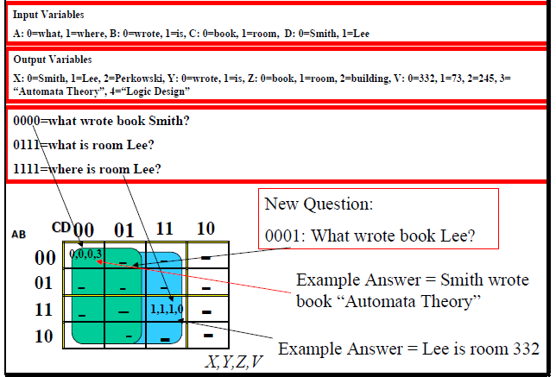
Figure 3.3. Question Answering by induction of answer parameters.

Question-answering example illustrates that exactly the same techniques and representations can be used to natural language processing and translation. The input sentences are encoded in multiple-valued logic and the output sentences are generated as a results of logic-synthesis-based generalization. There are several variants of this language learning technology, and here we use only the simplest possible example. Based on two examples the system infers incorrect but reasonable answer to the third question – “What wrote book Lee?” Observe that the answer will depend on the logic minimization procedure and MV prime implicants like C’ or D found in this particular case. There are many possible answers to induce in this case, including 1000 = “Lee wrote book 332”.

The example illustrates thus also certain randomness, that always exists in all generalization based methods such as Constructive Induction. Various texts are generated as results of different runs and logic minimization approaches. This method automatically generalizes answers in case of insufficient information. This is only a simplified example that does not take into account parsing and syntax. Variable values are only parameters that are instantiated to correct syntax generators – so ungrammatical sentences as in Fig. 3.3 are avoided. If robot’s response to question 0001 = What wrote book Lee? is wrong, it can be corrected by inserting to cell 0001 of Kmap a correct care minterm value, like 1004 = Lee wrote book “Logic Design”, which means, row 0001 1004 to the table.

4. Learning of Deterministic and Probabilistic State Machines.
The original method of human-robot interaction invented for the purpose of robot theatre and presented in its first variants here, has aspects of Supervised Learning (Section 3) and Reinforcement Learning (this section). A more detailed version of this paper will explain the ideas in detail. The main idea is however to build incrementally a state machine that has deterministic and probabilistic submachines. This machine is built in try-and-error typical to Reinforcement Learning, but the known RL algorithms are not used. Emotions of robots are programmed as probabilistic state machines. In the first version they are not learned from examples, but just programmed by the students. Example of a simple machine for a female receptionist robot is given in Figure 4.1. Probability of actions are denoted in red. Every internal state of the robot is denoted as a blue oval. The internal states can be states of dialog, states of information providing, emotional states or states of the script of the play.

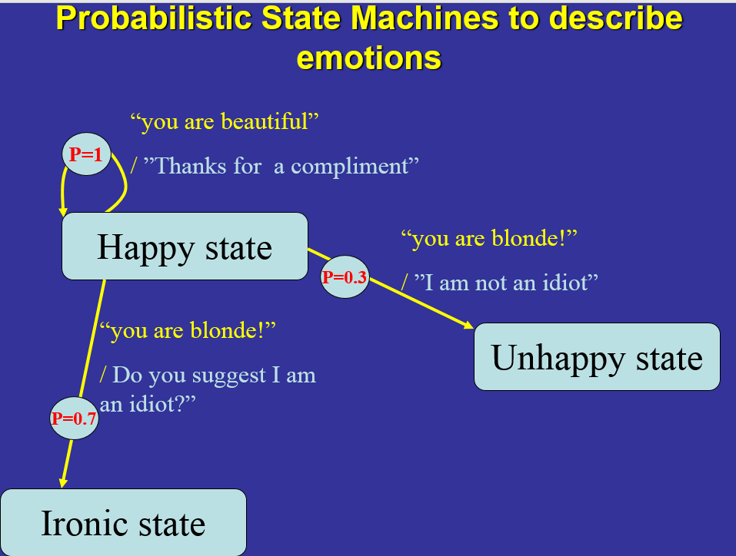
Figure 4.1. Example of robot emotions. Emotions are described as a probabilistic state machine with input symbols from the library of inputs and output symbols from the library of behaviors.

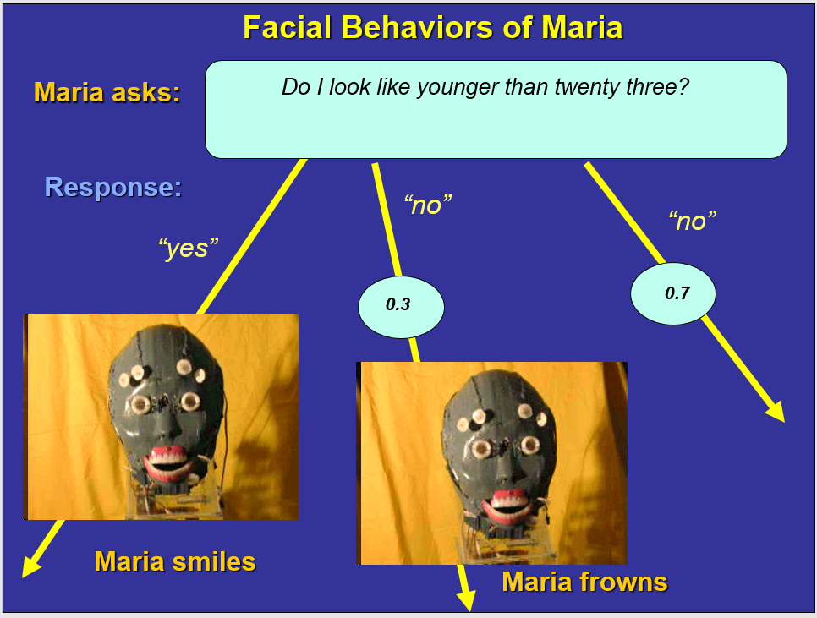
Figure 4.2. Example of robot emotions. Emotions are described as a probabilistic state machine with input symbols from the library of inputs and output symbols from the library of behaviors. The probabilistic behaviors can be encoded in states and outputs. They cause different robot responses to the same questions or input behaviors of the user.

The inputs to machines are all kind of information from sensors, cameras, Kinect devices or text. The outputs to machines can be text (converted to speech by text-to-speech software), music, lights, gestures of robot arms and legs, robot facial gestures, etc. There are two modes of dialog: (1) the user asks questions, (2) the robot asks questions. The grammars for question-answering are very simplified (a special paper is being prepared). For instance, there is always a pattern with word “who, what, why” etc.
The words are: who, what, when, why, how, how-many, where. Example of a sentence generator for a robot is presented in Figure 4.3. In conclusion, probabilistic and deterministic grammars are a base of creating state machines for the robot such as generators, acceptors and transformers.

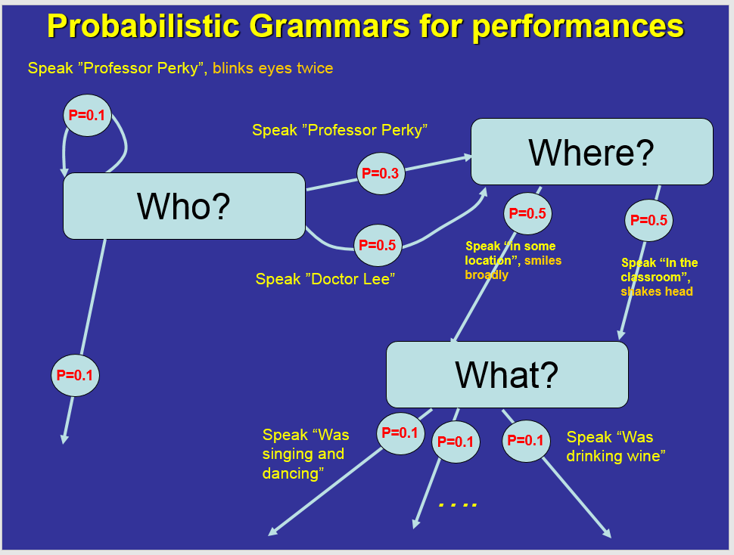
Figure 4.3. Example of robot random story generations. Output behaviors are described as a probabilistic autonomous state machine with output symbols from the library of behaviors. The probabilistic behaviors can be encoded in states and outputs. They cause different robot responses to the same questions or input behaviors of the user, which cause the robot to go to its autonomous generation sequence as illustrated here.

5. Example of changing internal states.
Robot behaviors are state machines, probabilistic, deterministic and mixed. Some are hierarchical. These machines are created “by hand” by the user, “learned in natural language conversation” or “learned from examples”.

The robot system presented in Figure 5.1 is a “supervisor” of our system. It is responsible for gestures and natural language text. It has five internal top-level states and is deterministic on this level of generality. The internal states of the robot are:
- Robot asks. This is the basic and starting state of the robot. In this state robot asks questions to the user. This is the initial state to which robot goes when it hears “Hello Maria”, “Hello Monster”, “Echo”, “Alexa” or “Amazon”. It remains in this state and asks questions until some keyword is used by the user which causes the robot to go to one of its other states: “robot performs”, “Human teaches”, “Human asks” or “Human commands”. Robot can sponteneously (randomly) go to state “robot performs” in which it stays doing tricks and funny poses until the user says “Stop performance”. Hearing this robot goes back to state “robot asks”.
- Human teaches. Robot enters this internal state when he hears the command “thanks, I have a lesson”. Word “lesson” is enough. In this state a human user (a visitor, a member of the theatre audience) teaches the robot by examples. When done, the command from the user “Lesson finished” leads the robot back to state “Robot asks”.
- Robot performs. Being in this state, robot executes any action from the library of behaviors. It can be random or is related to previous states, commands and behaviors.
- Human asks. In this state the human asks the question to the robot. Robot enters this state when it hears the command “Thanks I have a question”. Hearing word “question” is enough. The robot stays in this state and listens to questions, until the human says “questioning finished” with which robot goes back to state “robot asks” and confirms its state with “what can I do for you?”
- Human commands. In this state the robot immediately executes commands from the human. After executing a command from a human robot is ready to execute the next command and remains in state “human commands”. This state is reached from state “robot asks” by hearing the text “Thanks I have a command”. Word “Command” is enough. Currently the implemented commands are the following: (1) RightArm, (2) RightLeg, (3) LeftLeg, (4) LeftArm, (5) Head, (6) Funny, (7) Kick, (8)Wave, (9)Walk, (10)Salute, (11) Badboy, (12) Sprint, (13) Kneel, (14) Stroll.

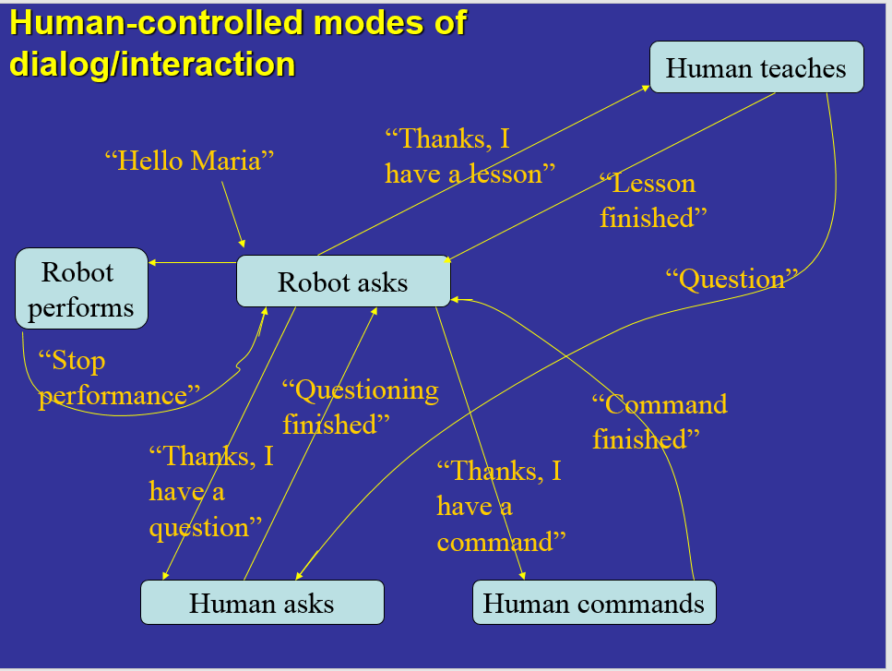
Figure 5.1. A robot system for robot called Maria. It has human-controlled modes of dialog and interaction with five internal states and a set of keywords. Similar systems are pre-programmed for various robot personalities, like Alexa, Monster and other. Not all labeled arrows are shown for simplification.

The robot is located behind the glass window of the laboratory, near a corridor that many people walk. Human motion detected by Kinect may cause the robot to go to the “Robot asks” state. Let us assume that the robot initiates conversation. This is an example of the “Robot-Receptionist Initiated Conversation”.
Robot is in its internal state “Robot asks” and asks the standard question “What can I do for you?” Thus the user knows in which state the robot is in. Suppose the user, a visitor to the lab, asks the question “I would like to order a table for two”. The robot remains in state “robot asks” and asks a question “Smoking or non-smoking”. The states of the robot and conversation are demonstrated on the monitor for checking and user/visitor information.
(a)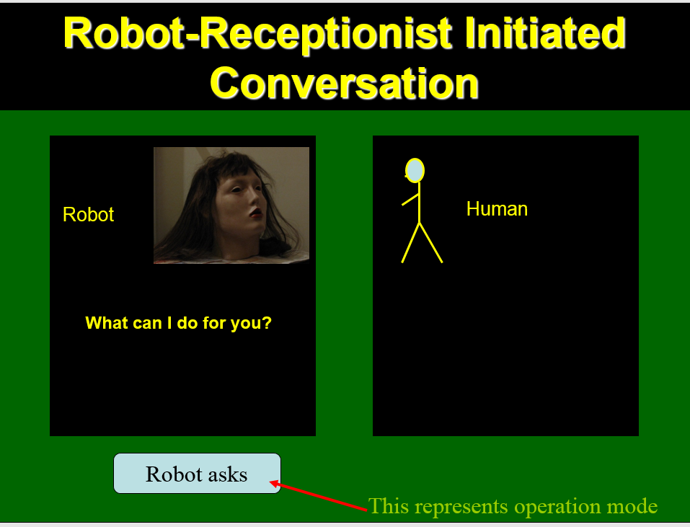 (b) 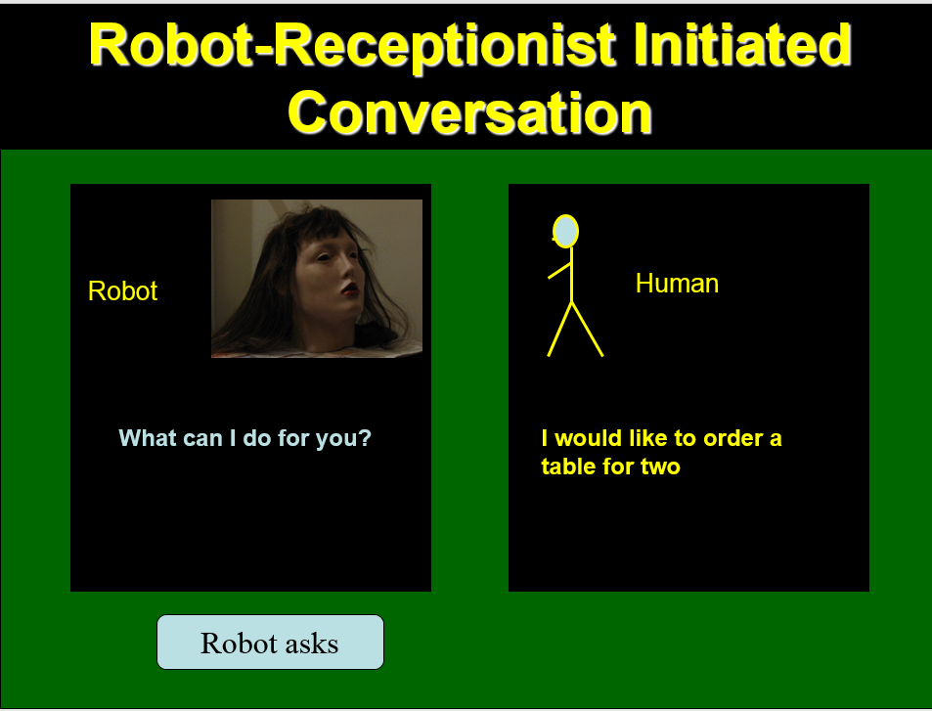
(c )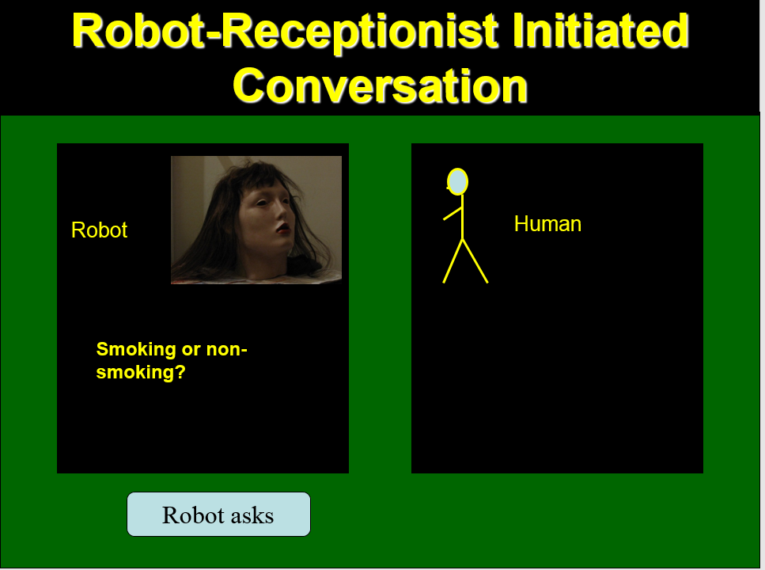(d)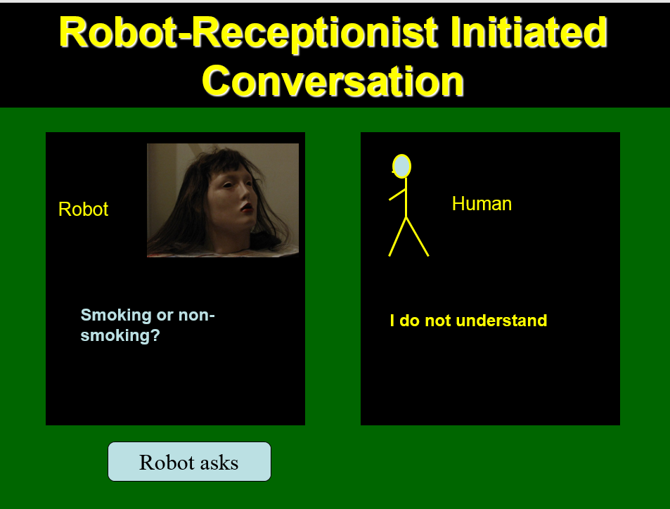
(e)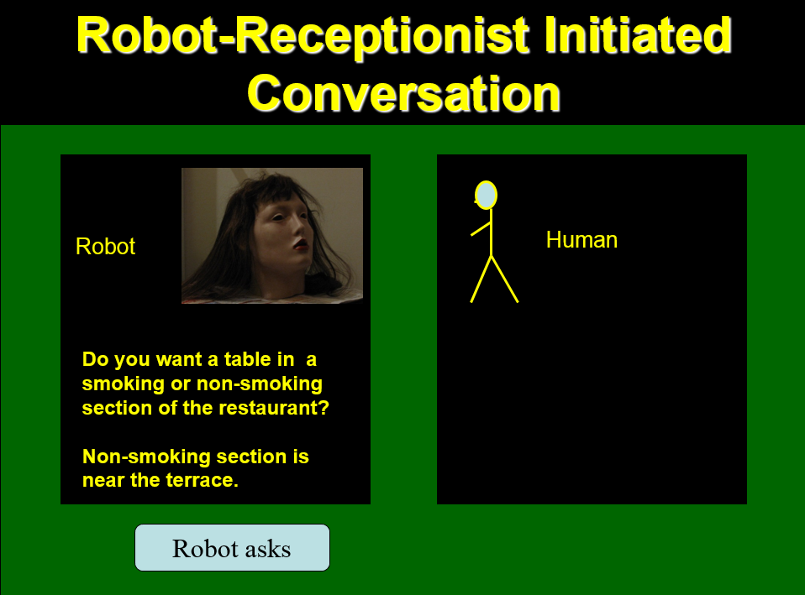 (f) 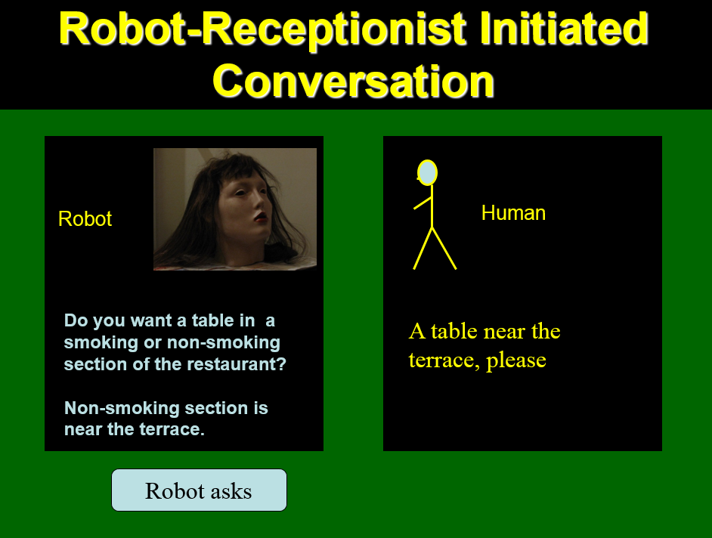
Figure 5.2. A robot system for robot called Maria from Figure 5.1. Snapshots illustrate a conversation/interaction that was initiated by the robot.

- 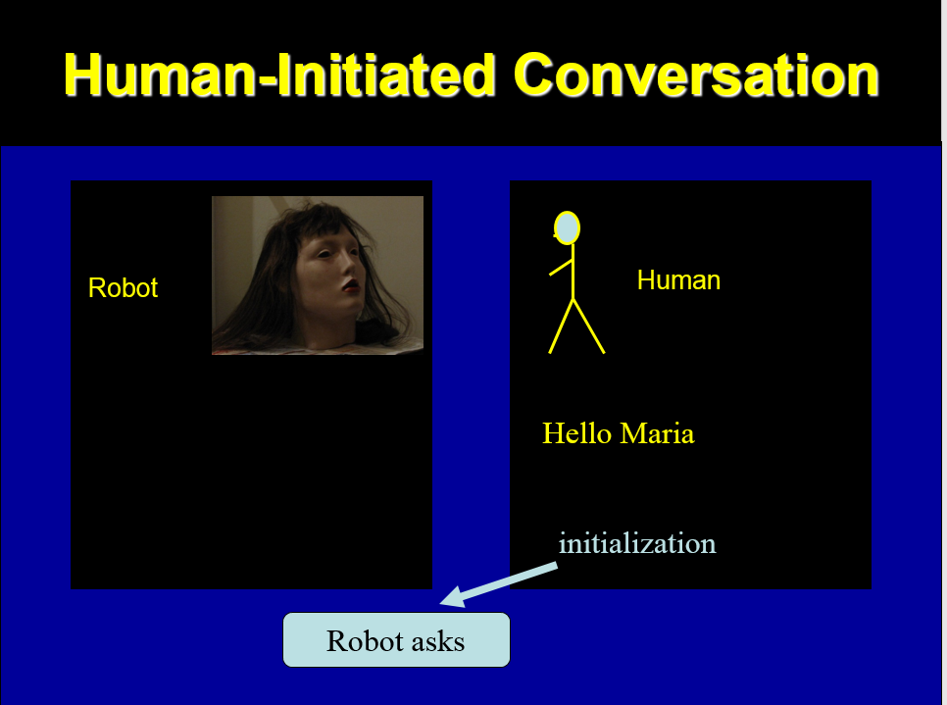(b)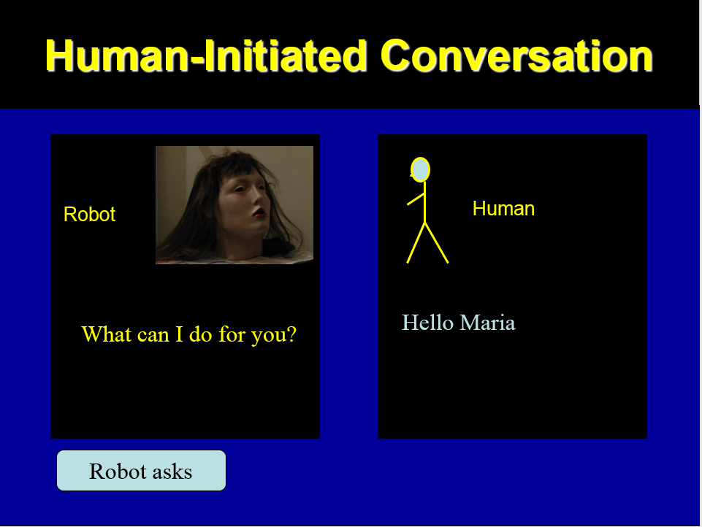
(c )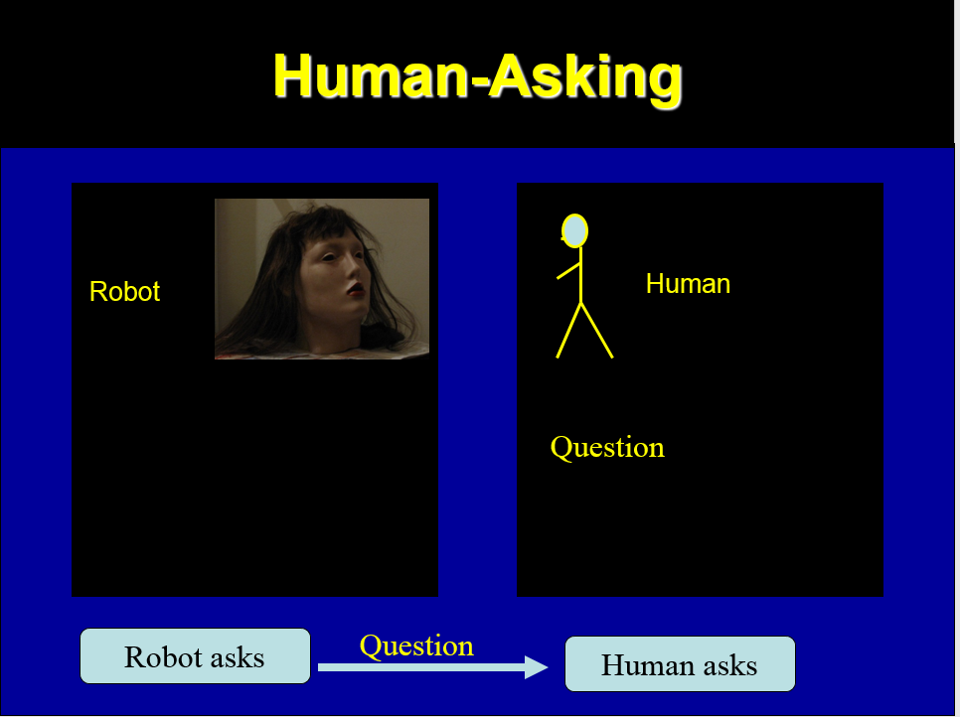(d) 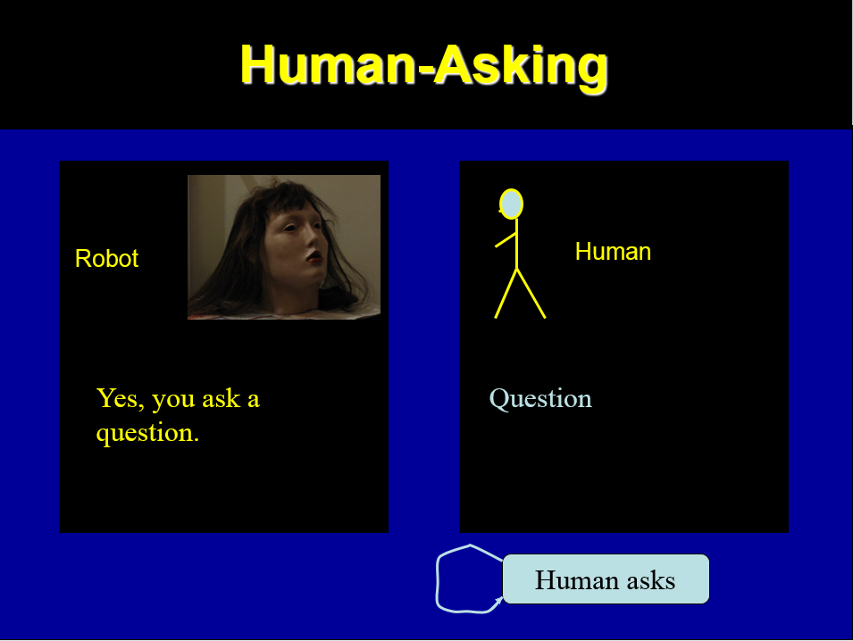
(e)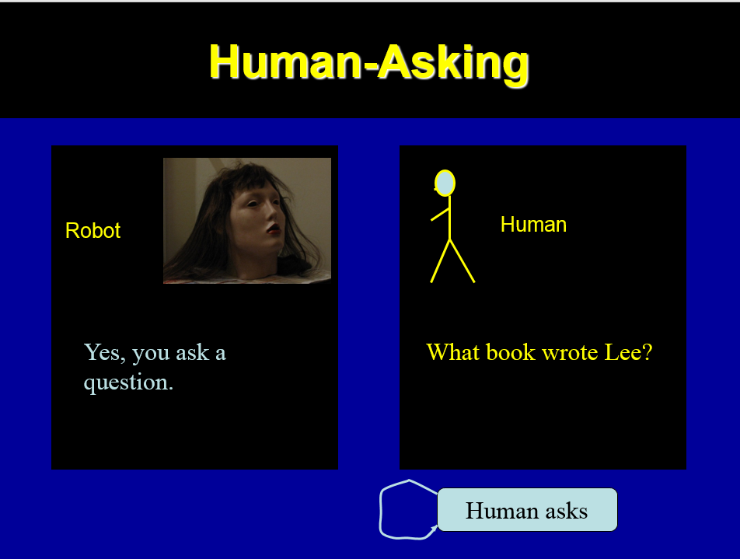 (f) 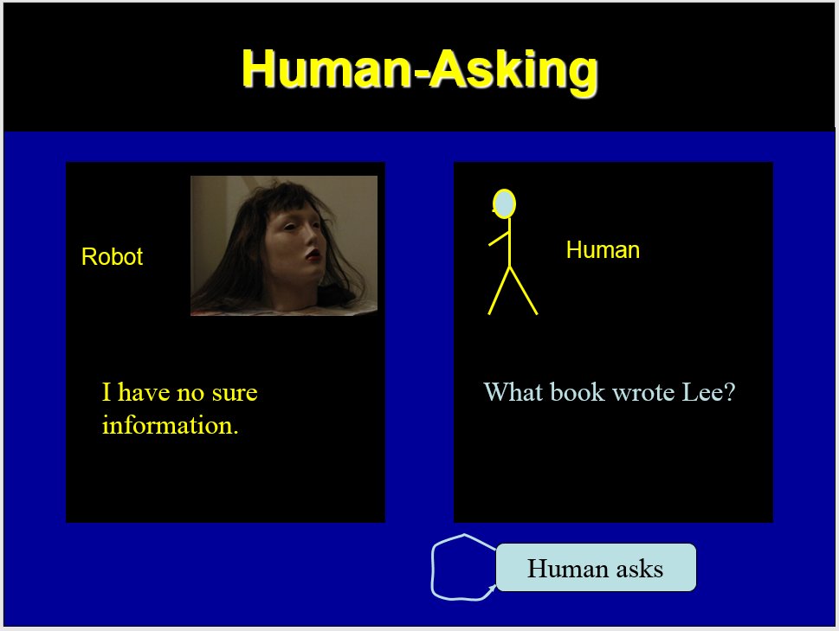
(g) 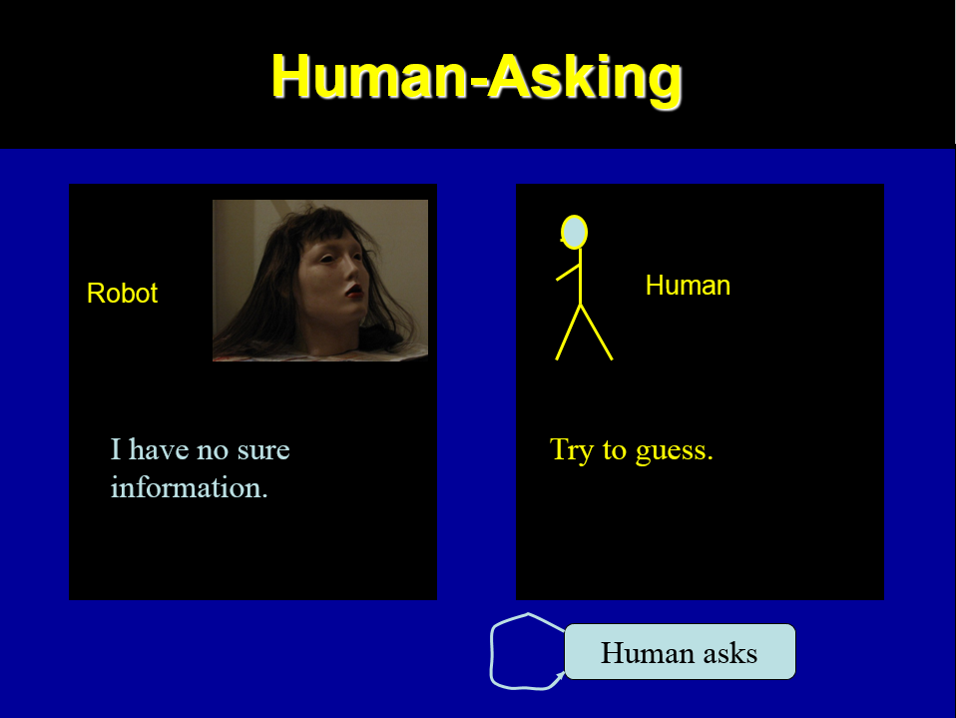 (h) 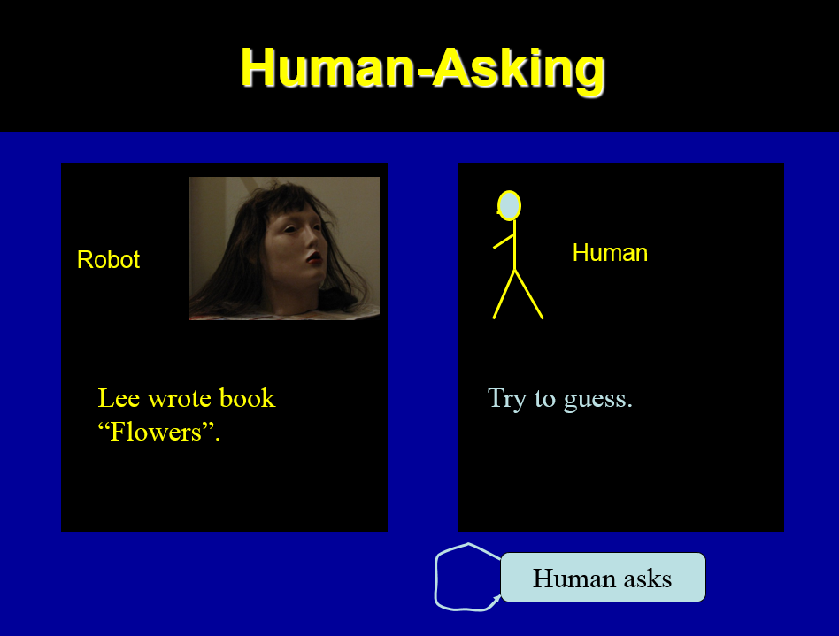
(i) 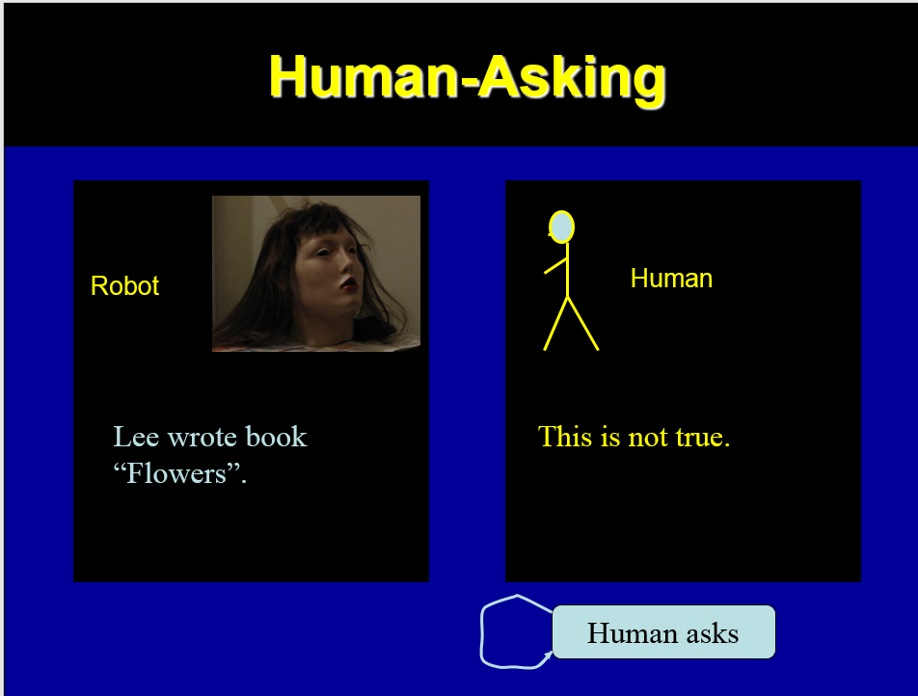 (j) 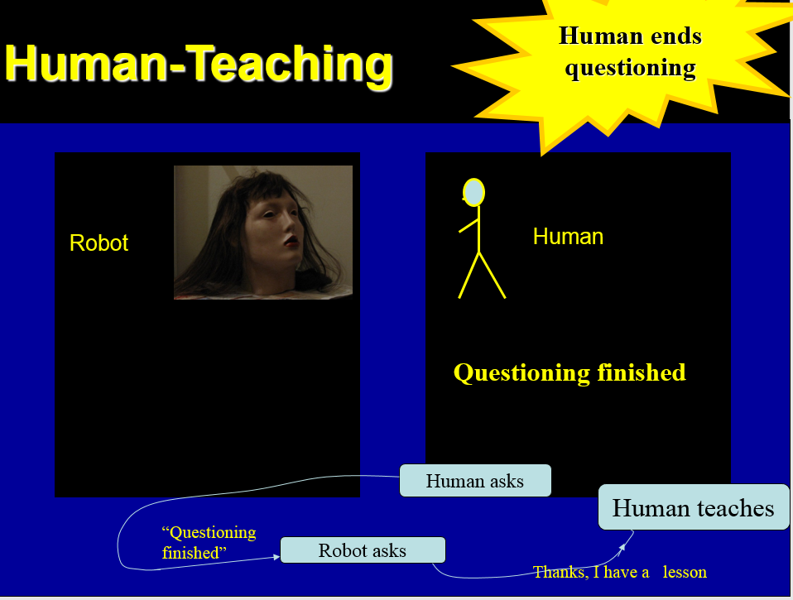
(k) 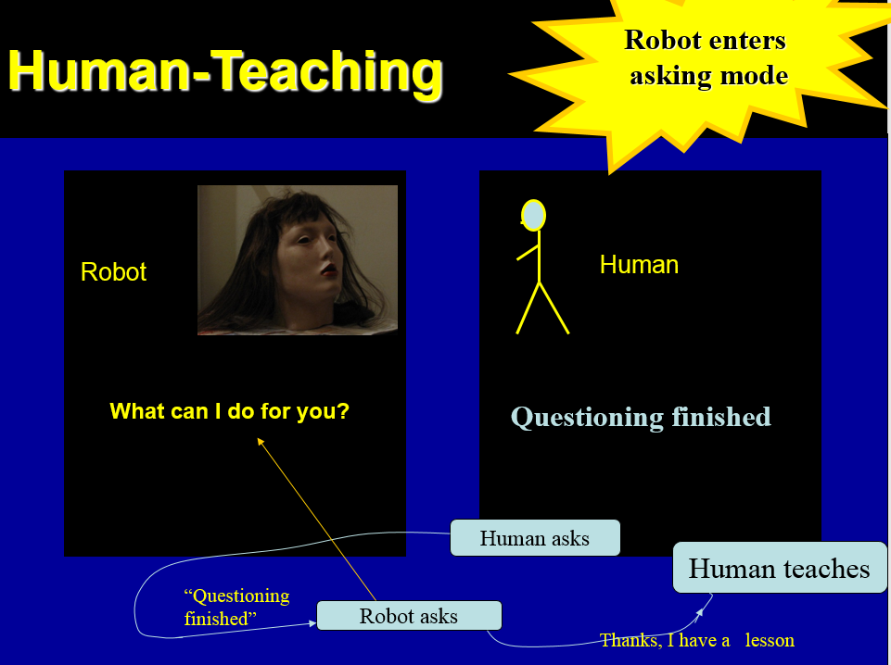
Figure 5.3. A robot system for robot called Maria from Figure 5.1. Snapshots illustrate a conversation/interaction that was initiated by the human, who wants to check if the robot knows correctly answers to some questions. The robot remains in state “human asks” until the human, not satisfied with robot’s knowledge ends the asking session by telling “questioning finished”. This causes the robot to go to the “robot asks” state and confirm with sentence “what can I do for you”.

(a)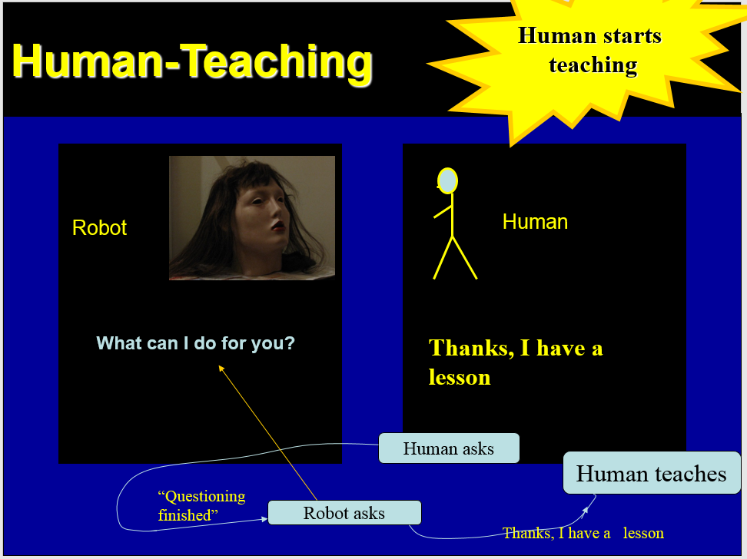 (b)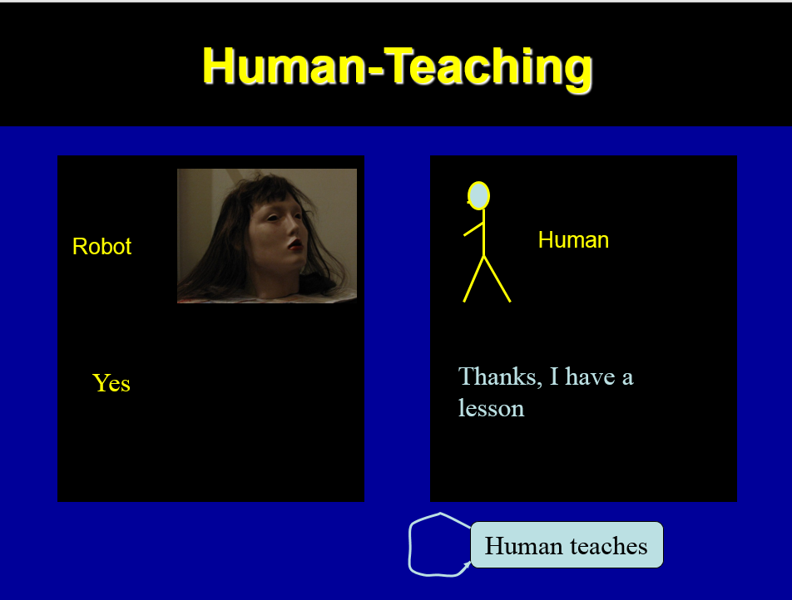
(c )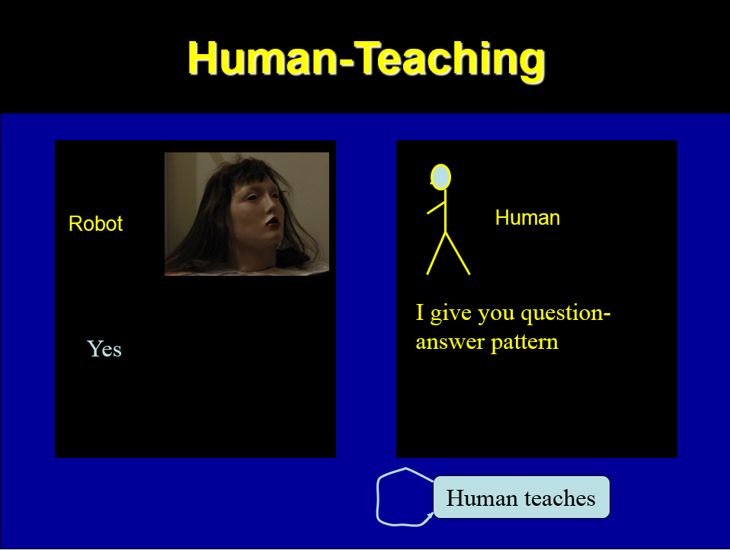 (d ) 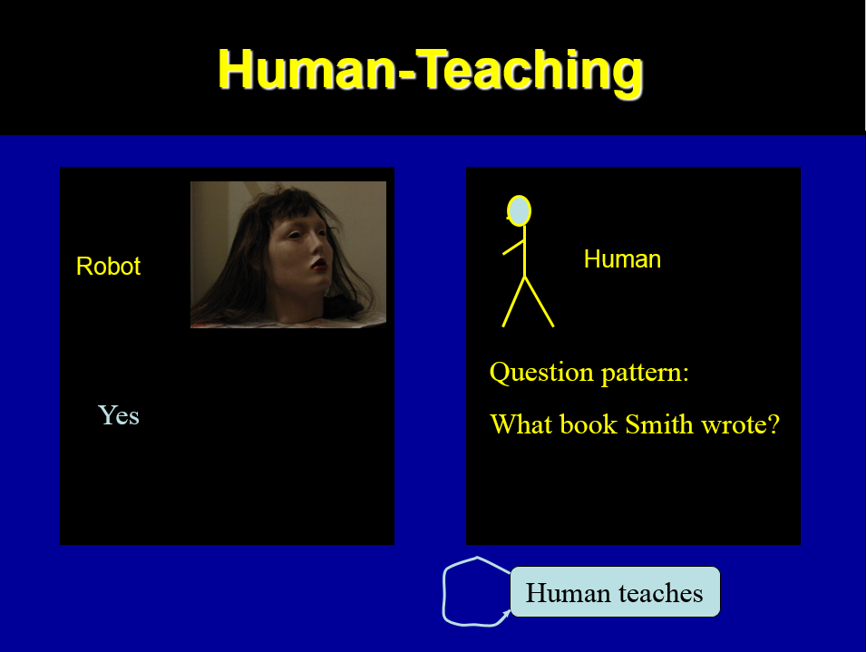
(e)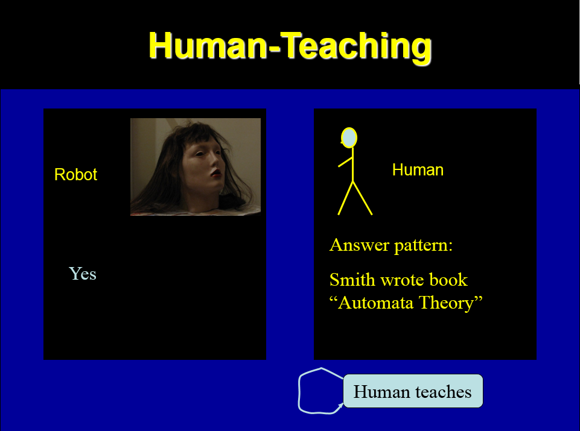 (f)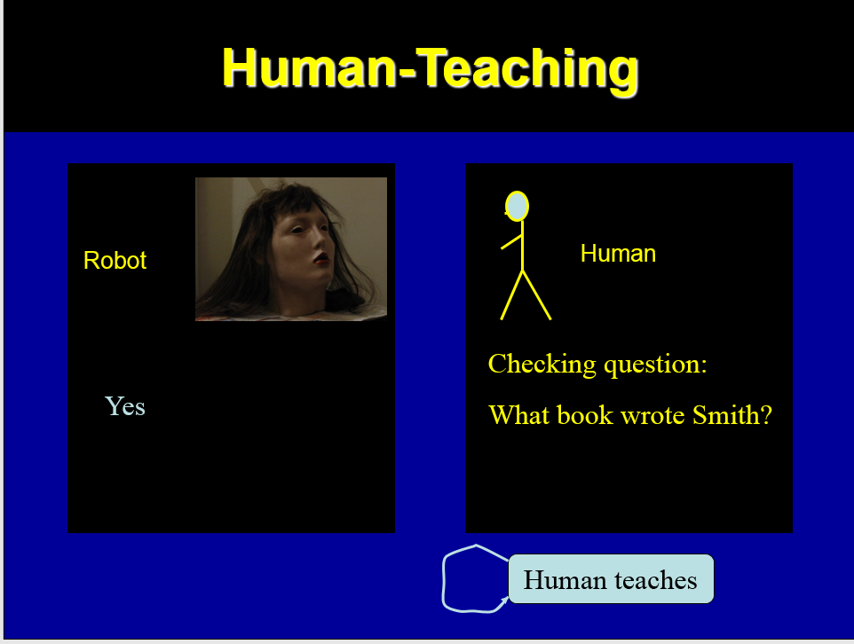
(g)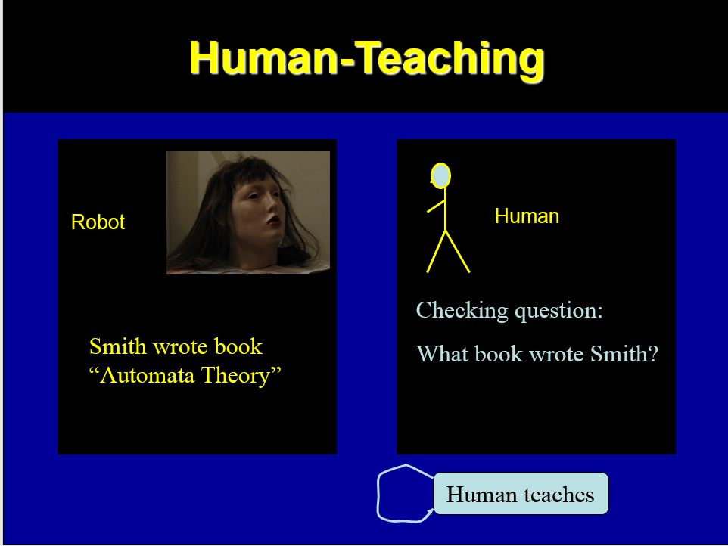 (h)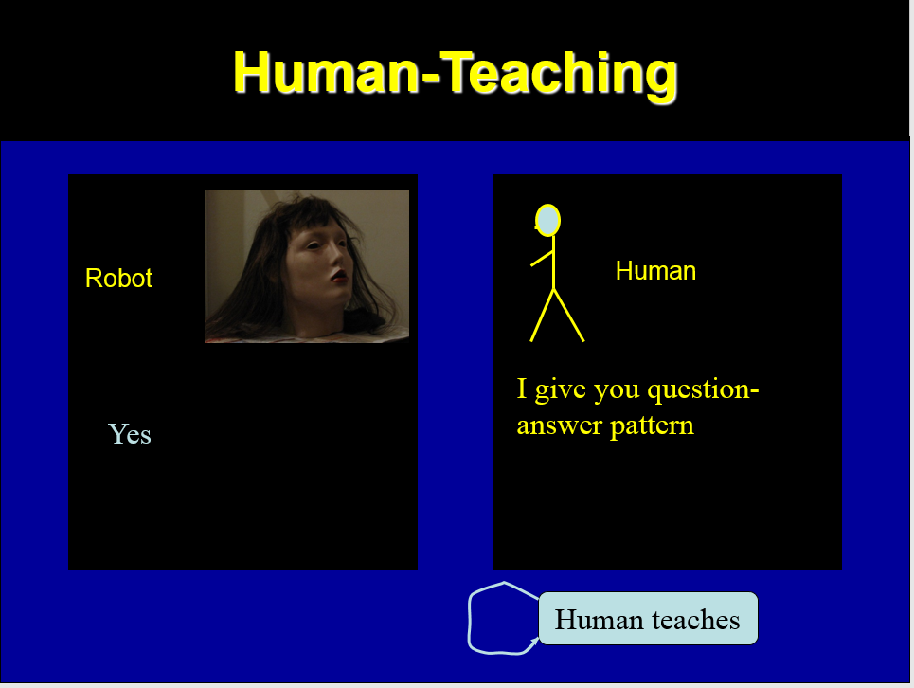
(i)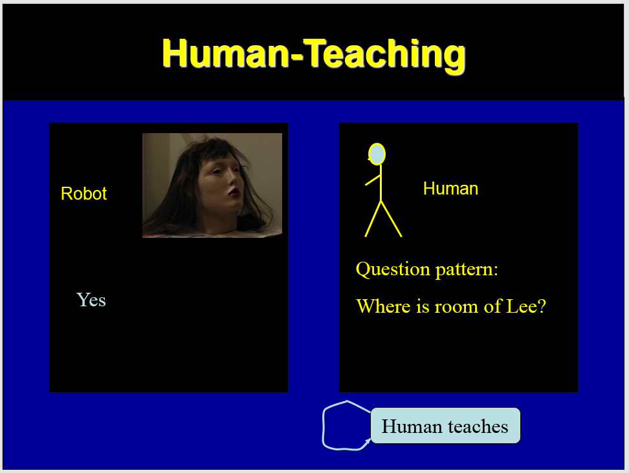 (j)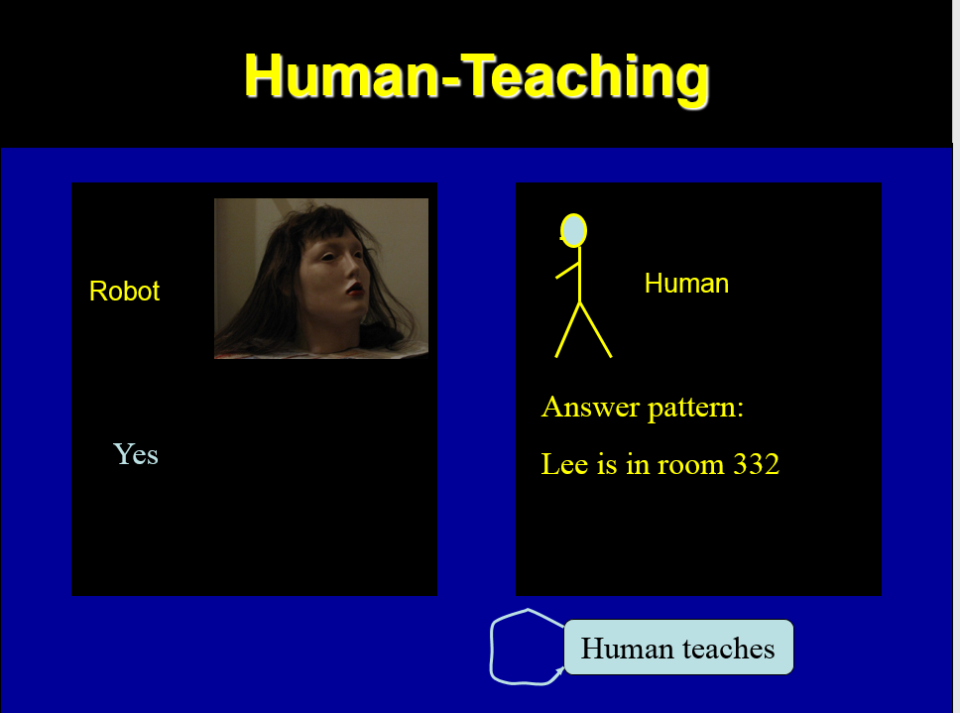
(k)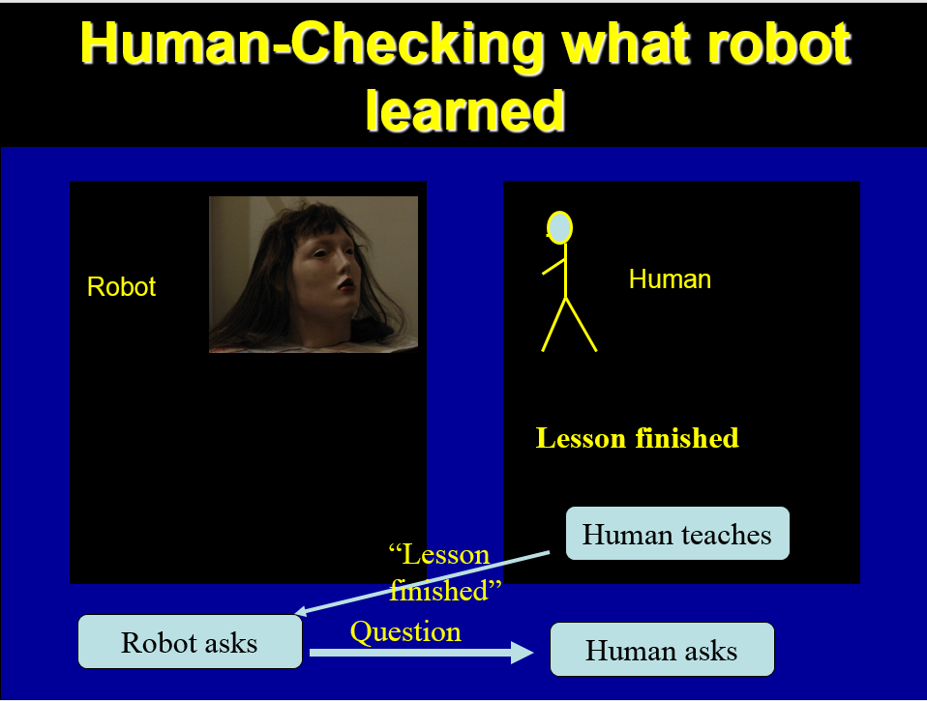 (l) 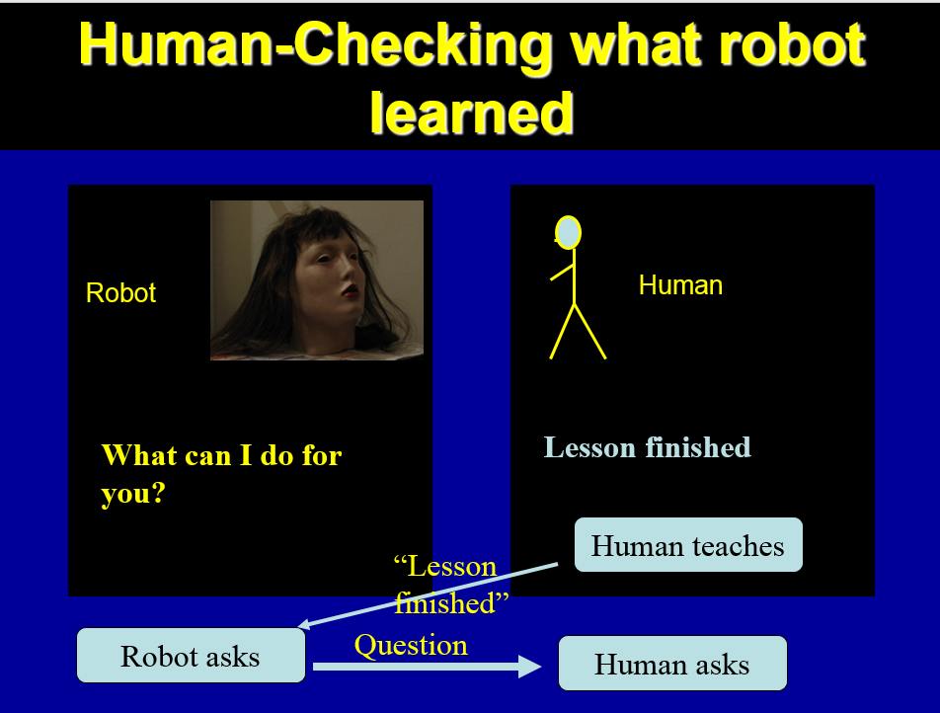
Figure 5.4. A robot system for robot called Maria from Figure 5.1. Snapshots illustrate a conversation/interaction in which a human teaches the robot using natural language. After teaching phase, the human checks if the robot learned correctly.

(a) 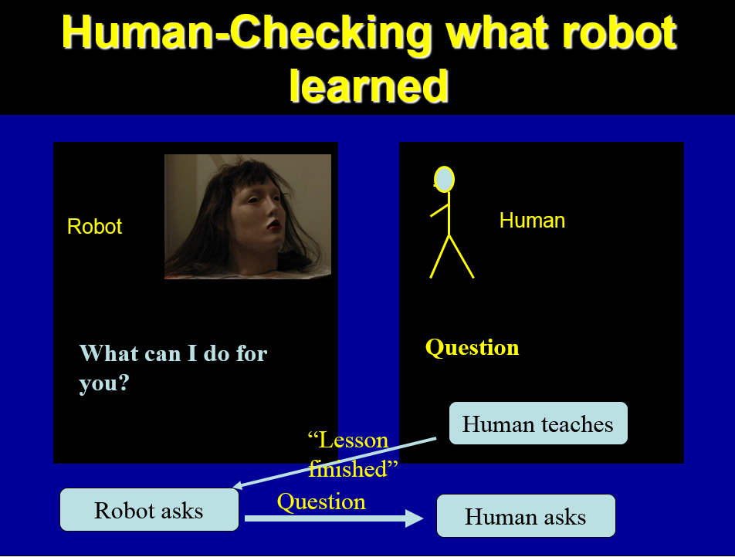 (b)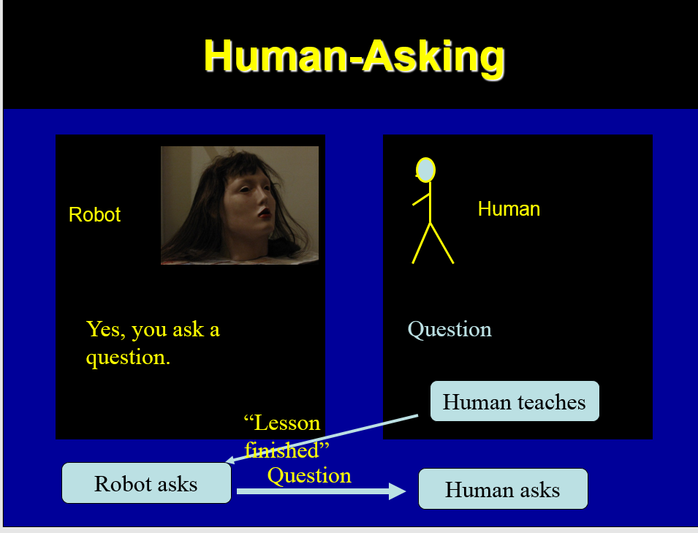
(c )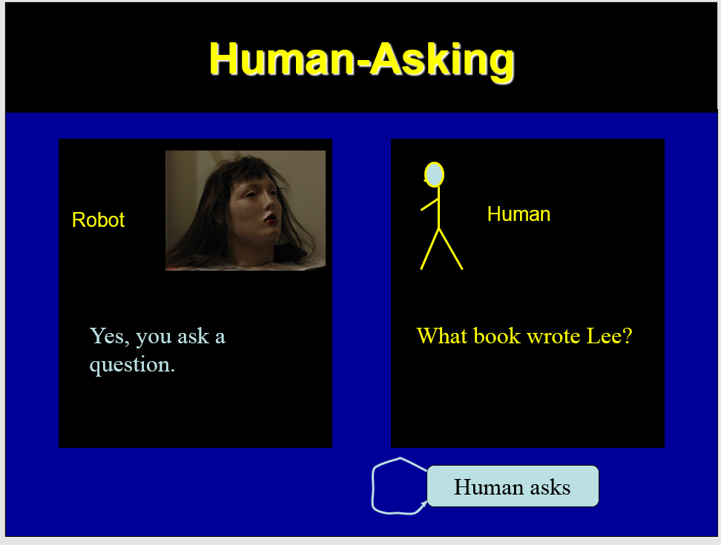 (d) 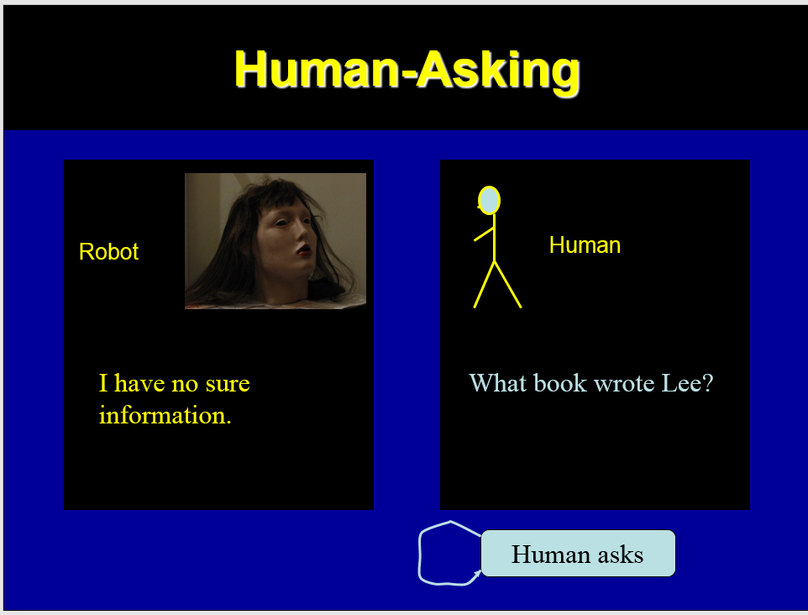
(e)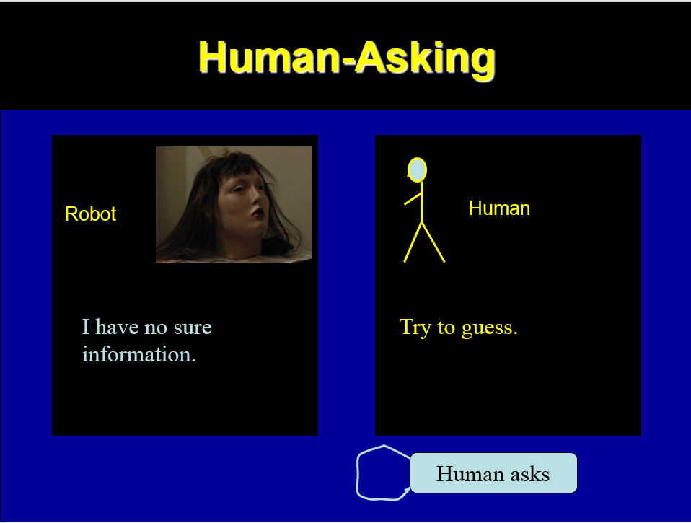 (f)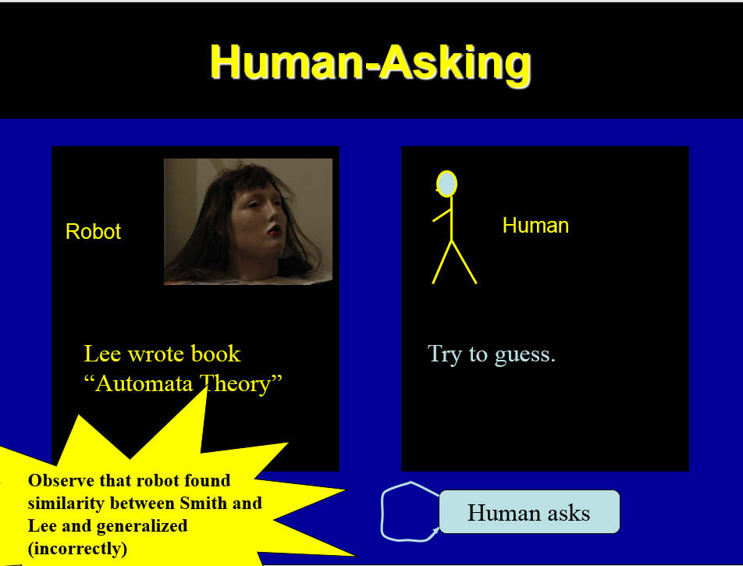

Figure 5.5. A robot system for robot called Maria from Figure 5.1. Snapshots illustrate a conversation/interaction that was initiated by the human to check if the robot learned correctly what was taught in “human teaches” state.

6. Conclusion. What did we learn

A demonstration entertainment/receptionist robot was built in a form of a modern Frankenstein’s Monster, called Anchor Monster. We gained some new experience by building this robot, one more in a series of “Sonbi-like” robots started with Sonbi:
- Best available ATR and TTS packages should be applied, especially those that use word spotting. This is why we decided to use Alexa [ref] together with Microsoft tool and Alice [ref].
- the designer should look to new materials and in general learn from puppet theatre experiences in many areas, such as puppet design, stage design and audio, movement animation, speech, facial gestures,
- because of a too slow learning, improved parameterized learning methods will be developed, but also based on constructive induction,
- although robot face should be funny, it should not be ugly – based on these experiences with Professor Perky, we build now a new robot Maria.

The bi-decomposer of relations and other useful software used in this project can be downloaded from http://wwwcad.eecs.berkeley.edu/mvsis/.

One of our future goals is the “Turing Test for Robotic Puppets”. This test will be organized to answer two questions:
- “can the audience distinguish if the robot puppet Anchor Monster is animated remotely by a human (hidden and not seen by the audience, but being able to see the robot and audience reactions), or if its language/gesture behavior is entirely autonomous?”
- “can the audience distinguish between Anchor Monster behavior that was programmed by a human and the robot’s behavior that was learned from examples?”

5. Literature
- M. Perkowski, Oregon Cyber Theatre, Proc. 3rd Oregon Symposium on Logic, Design and Learning, May 2000.
- U. Wong and M. Perkowski, A New Approach to Robot’s Imitation of Behaviors by Decomposition of Multiple-Valued Relations, Proc. 5th Intern. Workshop on Boolean Problems, Freiberg, Germany, Sept. 19-20, 2002, pp. 265-270.
- A. Mishchenko, B. Steinbach and M. Perkowski, An Algorithm for Bi-Decomposition of Logic Functions, Proc. DAC 2001, June 18-22, Las Vegas, pp. 103-108.
- A. Mishchenko, B. Steinbach and M. Perkowski, Bi-Decomposition of Multi-Valued Relations, Proc. 10t ^{h} IWLS, pp. 35-40, Granlibakken, CA, June 12-15, 2001. IEEE Computer Society and ACM SIGDA.
- M. Perkowski, and S. Grygiel, Decomposition of Relations: A New Approach to Constructive Induction Proc. Workshop of National Inst. Of Telecommunications and Polish Association for Logic and Philosophy of Science, May 25, 2001, pp. 91-111, Warsaw, Poland.
- Ch. Finch, Ch. Finch and J. Henson, Jim Henson: The Works: The Art, The Magic, the Imagination, see also other books by and about Jim Henson on Amazon.com.
- A. Edsinger, U-M. O’Reilly, and C. Breazeal, A Face for a Humanoid Robot, MIT Memo, 2002.
- F.Hara, H.Kobayashi, F.Iida, and M. Tabata, Personality characterization of animate face robot through interactive communication with Human, Proc.1st Int’l Workshop on Humanoid and Human Friendly Robots, pp. 1-10, 1998.
- C. Breazeal, Sociable Machines: Expressive Social Exchange Between Humans and Robots, Ph.D. Thesis, MIT, 2000.
- A.Edsinger and U-M. O’Reilly, Designing a Humanoid Robot Face to Fulfill a Social Contract, MIT Memo, 2002
- C. Breazeal and B.Scassellati, Infant-like social interactions between a robot and a human caretakes, In Adaptive Behavior, August 2000.
- A.Edsinger and U-M. O’Reilly, Designing a Humanoid Robot Face to Fulfill a Social Contract, MIT Memo, 2002
- C. Breazeal and B.Scassellati, Infant-like social interactions between a robot and a human caretakes, In Adaptive Behavior, August 2000.
- M. Perkowski et al, “Listening and Talking Robot Heads,” KAIST Technical Report, 2003.
- Frankenstein Final Voice Recognition https://www.youtube.com/watch?v=bfsBNZnKE-c
- Frankenstein Gesture: https://www.youtube.com/watch?v=LfHExKT95BI
- Fuzzy Logic Demo:https://www.youtube.com/watch?v=UKbPCnX2sfU&feature=youtu.be
- Genetic Algorithm: https://www.youtube.com/watch?v=yKYRfGHoIF0
- Kick that Broke the Servo: https://www.youtube.com/watch?v=3OwX1x9Urp8
- Stasney etc report Fall 2016
- Report previous students
- Paper old

